# GUVI: Zen Class — Part 2 : Find the culprits and nail them — debugging javascript loops

1. Write a code to print the numbers in the array

var numsArr = [1, 2, 3, 4, 5, 6, 7, 8, 9, 10, 11];

var new_string = "";

for (var i = 0; i < 11; i++) {

new_string = new_string.concat(numsArr[i].toString())

}

console.log(new_string);

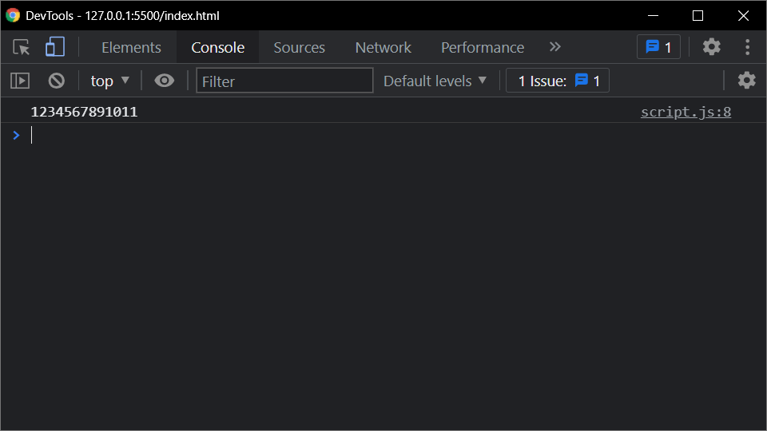

1. Write a code to print the numbers in the array

var numsArr = [1, 2, 3, 4, 5, 6, 7, 8, 9, 10, 11];

var new_string = "";

for (var i = 0; i < 11; i++) {

new_string = new_string.concat(numsArr[i].toString()+",")

}

console.log(new_string.slice(0,-1));

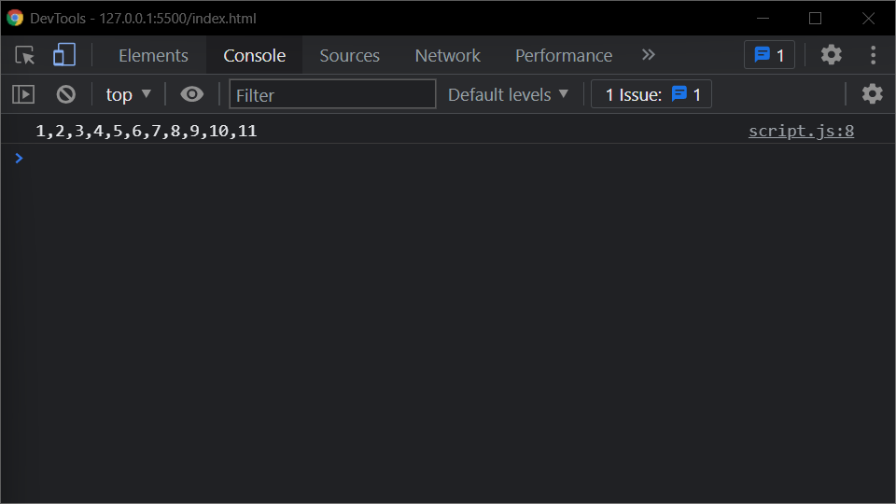

1. Write a code to print from last to first with spaces (Make sure there is no space after the last element 1)

var numsArr = [1, 2, 3, 4, 5, 6, 7, 8, 9, 10, 11];

var new_string = "";

numsArr.reverse()

for (var i = 0; i < 11; i++) {

new_string = new_string.concat(numsArr[i].toString()+" ")

}

console.log(new_string.slice(0,-1));

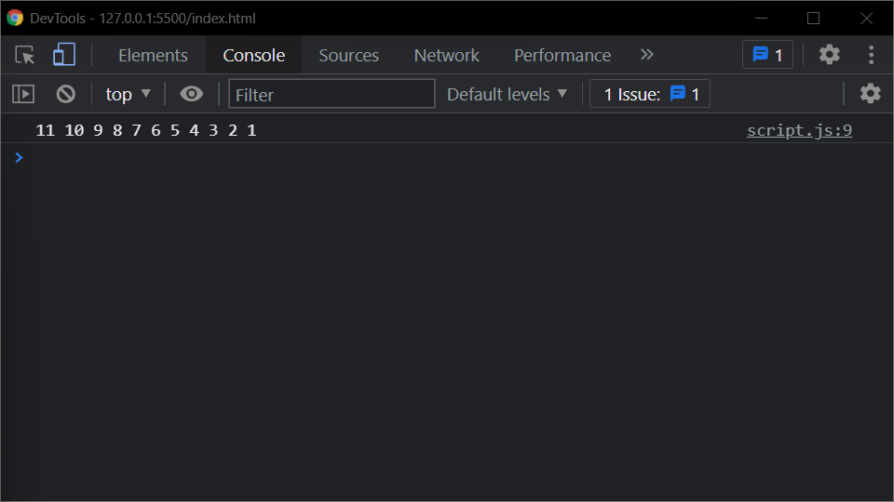

1. Write a code to replace the array value — If the number is even, replace it with ‘even’.

var numsArr = [ 1, 2, 3, 4, 5, 6, 7, 8, 9, 10, 11];

for (var i = 0; i <=10; i++) {

if(numsArr[i] %2 == 0 )

{

numsArr[i] = "even"

}

}

console.log(numsArr);

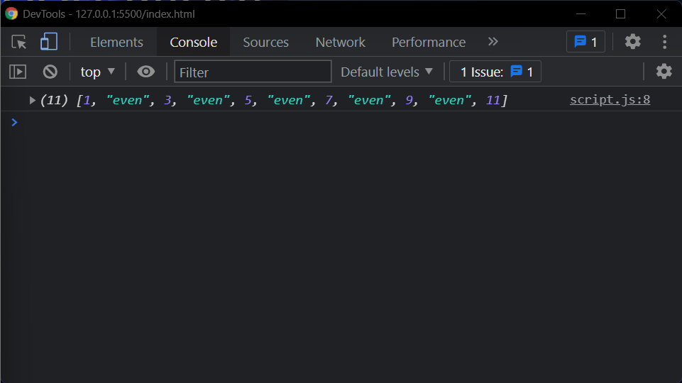

1. Write a code to replace the array value — If the index is even, replace it with ‘even’.

var numsArr = [ 1, 2, 3, 4, 5, 6, 7, 8, 9, 10, 11];

for (var i = 0; i <=10; i++) {

if(i %2 == 0 )

{

numsArr[i] = "even"

}

}

console.log(numsArr);

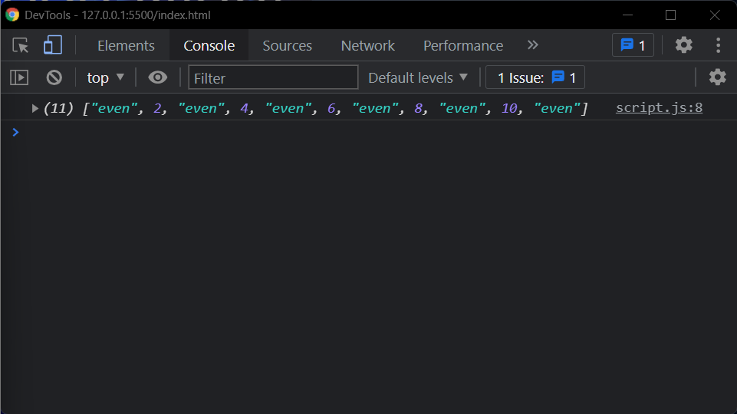

1. Write a code to add all the numbers in the array

var numsArr = [ 1, 2, 3, 4, 5, 6, 7, 8, 9, 10, 11];

var sum = 0;

for (var i = 0; i <=10; i++) {

sum += numsArr[i];

}

console.log(sum);

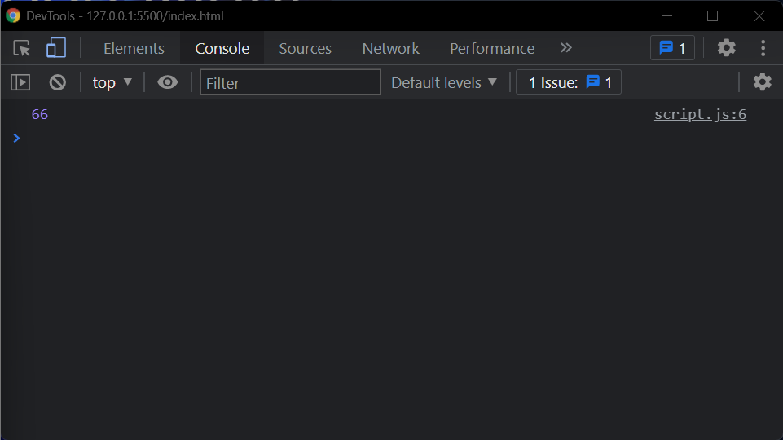

1. Write a code to add the even numbers only

var numsArr = [ 1, 2, 3, 4, 5, 6, 7, 8, 9, 10, 11];

var sum = 0;

for (var i = 0; i <=10; i++) {

if(numsArr[i]%2==0)

sum += numsArr[i];

}

console.log(sum);

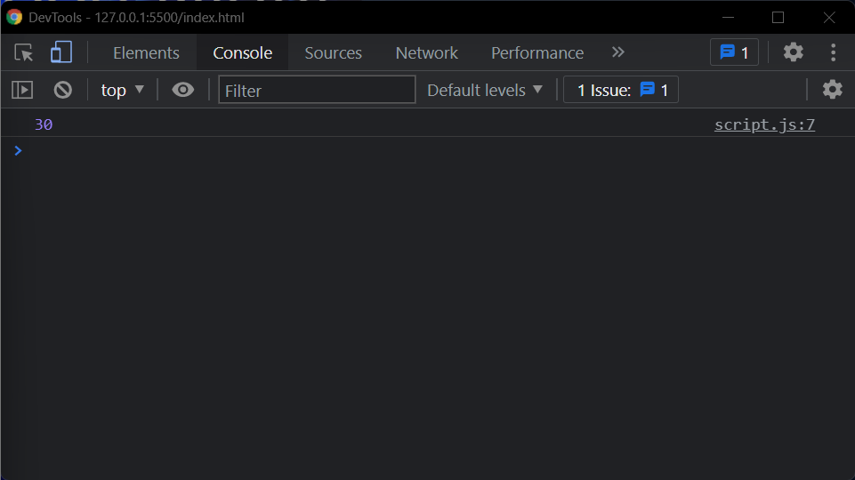

1. Write a code to add the even numbers and subract the odd number

var numsArr = [ 1, 2, 3, 4, 5, 6, 7, 8, 9, 10, 11];

var sum=100;

let even =0, odd =0;

for (var i = 0; i <=10; i++) {

if(numsArr[i]%2!=0)

{

odd += numsArr[i]

}

else

{

even += numsArr[i]

}

}

console.log(sum+even-odd);

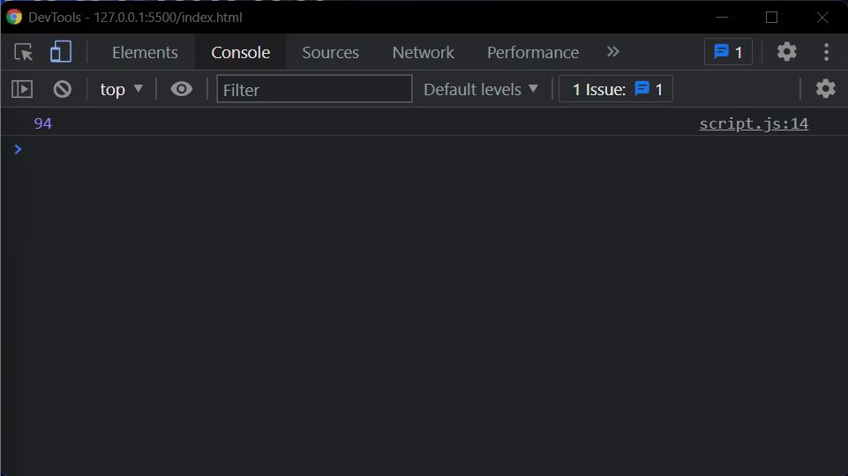

1. Write a code to print inner arrays

var numsArr = [[1, 2, 3, 4, 5],[ 6, 7, 8, 9, 10, 11]];

for(let i = 0; i < numsArr.length; i++) {

console.log(numsArr[i])

}

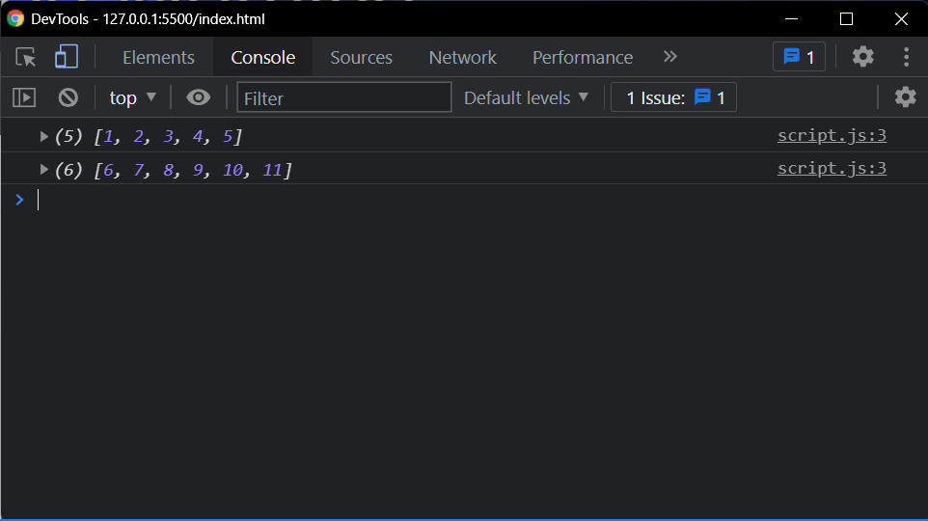

1. Write a code to print elements in the inner arrays

var numsArr = [[1, 2, 3, 4, 5],[ 6, 7, 8, 9, 10, 11]];

var str_all = "";

for(var i = 0; i < numsArr.length;i++){

var inner_array = numsArr[i];

for(var j = 0 ; j < inner_array.length;j++ )

str_all += inner_array[j].toString();

}

console.log(str_all);

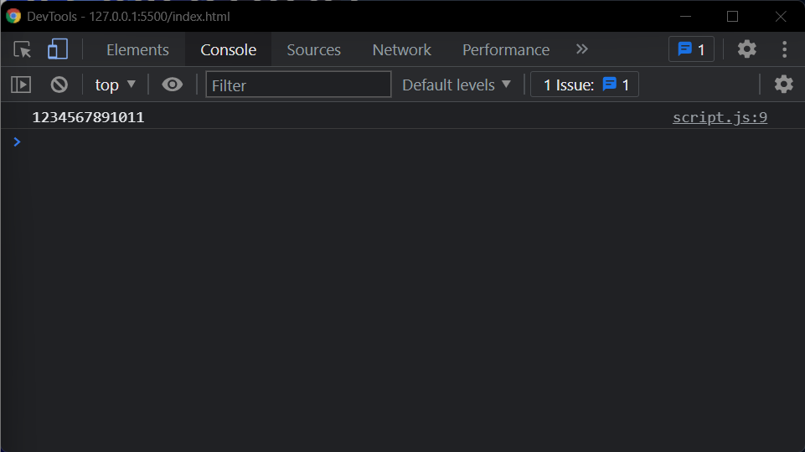

1. Write a code to replace the array value — If the index is even, replace it with ‘even’.

let numsArr = [[1, 2, 3, 4, 5],[ 6, 7, 8, 9, 10, 11]];

for (var i = 0; i < numsArr.length; i++) {

var inner_array = numsArr[i];

for(var j = 0 ; j < inner_array.length;j++ )

if(j %2 == 0 )

{

numsArr[i][j] = "even";

}

}

console.log(numsArr);

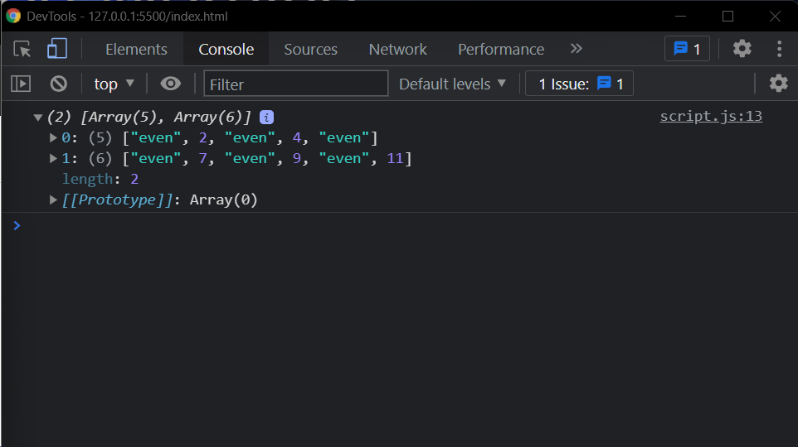

1. Write a code to print elements in the inner arrays in reverse

let numsArr = [[1, 2, 3, 4, 5],[ 6, 7, 8, 9, 10, 11]];

let str_all = "";

for (let i = numsArr.length-1; i >=0 ; i--) {

let inner_array = numsArr[i];

for(let j = inner_array.length-1; j >= 0 ;j-- ){

str_all += inner_array[j].toString() + " ";

}

}

console.log(str_all.slice(0,-1));



1. Write a code to add elements in the inner arrays based on odd or even values

let numsArr = [[1, 2, 3, 4, 5],[ 6, 7, 8, 9, 10, 11]];

let sum_odd=0;

let sum_even=0;

for (let i = 0; i < numsArr.length; i++) {

let inner_array = numsArr[i];

for(let j = 0 ; j < inner_array.length;j++ ){

if(numsArr[i][j]%2!=0)

{

sum_odd += numsArr[i][j]

}

else

{

sum_even += numsArr[i][j]

}

}

}

console.log(sum_odd);

console.log(sum_even);

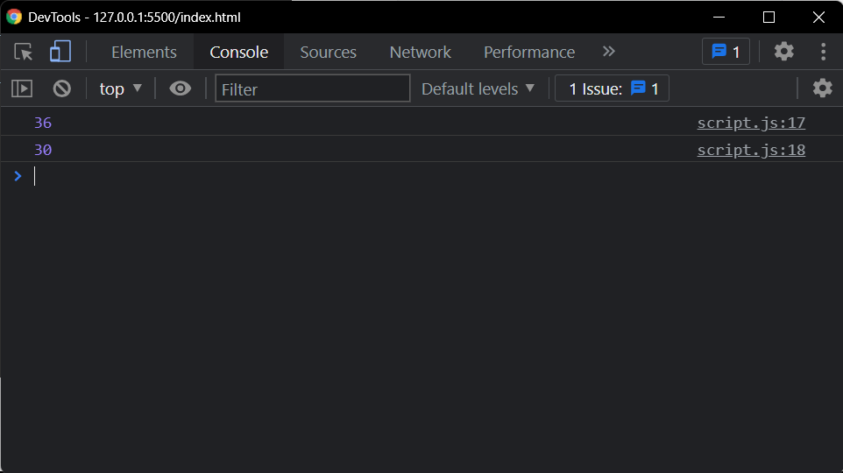

# GUVI: Zen Class — Part 3: Find the culprits and nail them — debugging javascript

1. Fix the code to get the largest of three.

aa = (f,s,t) => {

console.log(f,s,t);

if(f>s &&f>t){

console.log(f)}

else if(s>f && s>t){

console.log(s)}

else{

console.log(t)}

}

aa(1,2,3);

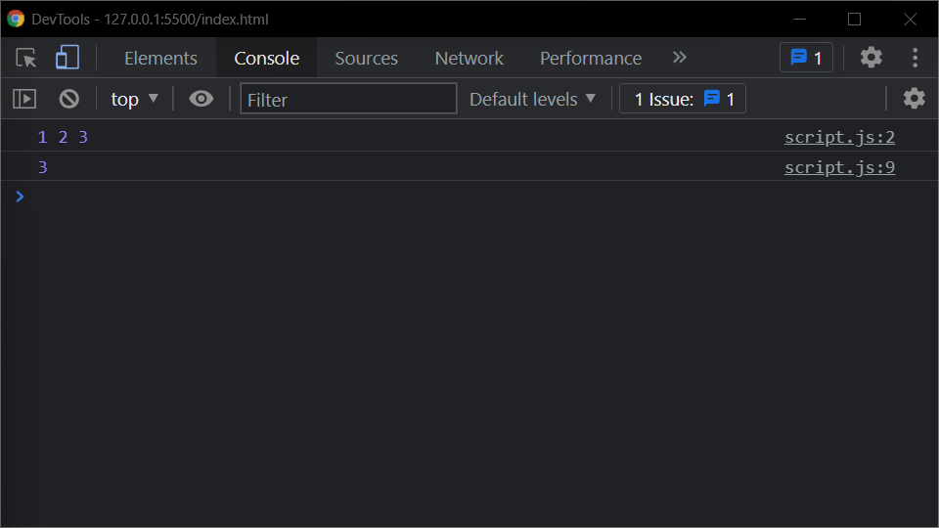

1. Fix the code to Sum of the digits present in the number

let n = 123;

console.log(add(n));

function add(n)

{

let sum = 0;

n = String(n).split('')

for(var i=0;i<n.length;i++){

sum+= parseInt(n[i])

}

return sum;

}

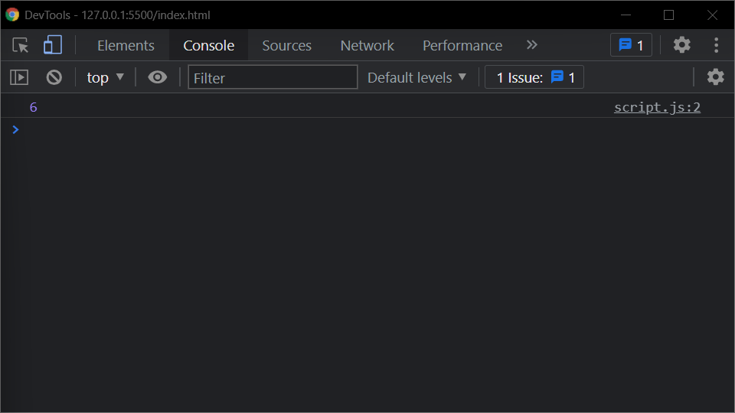

1. Fix the code to Sum of all numbers using IIFE function

const arr = [9,8,5,6,4,3,2,1];

(function() {

let sum = 0;

for (var i = 0; i <= arr.length-1; i++){

sum += arr[i];

}

console.log(sum);

return sum;

})();

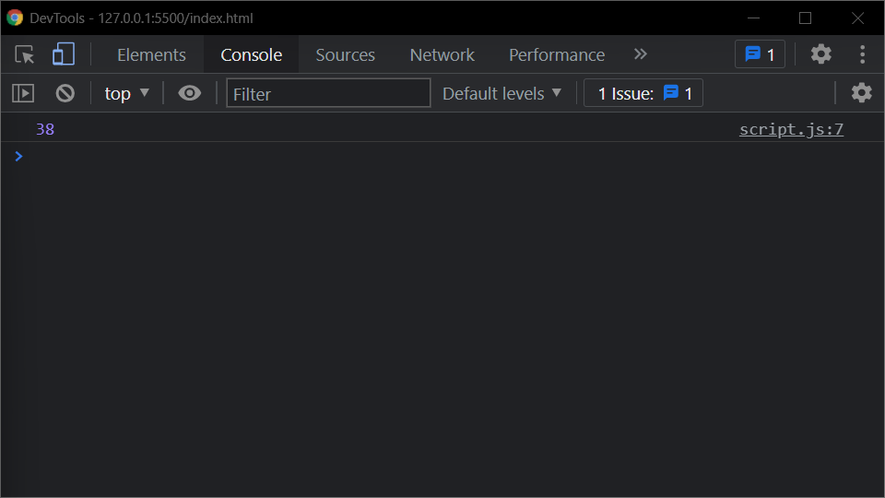

1. Fix the code to gen Title caps.

let arr = ["guvi", "geek", "zen", "fullstack"];

let ano = function() {

for(let i = 0; i <= arr.length-1; i++) {

console.log(arr[i].charAt(0).toUpperCase() + arr[i].slice(1));

}

}

ano();

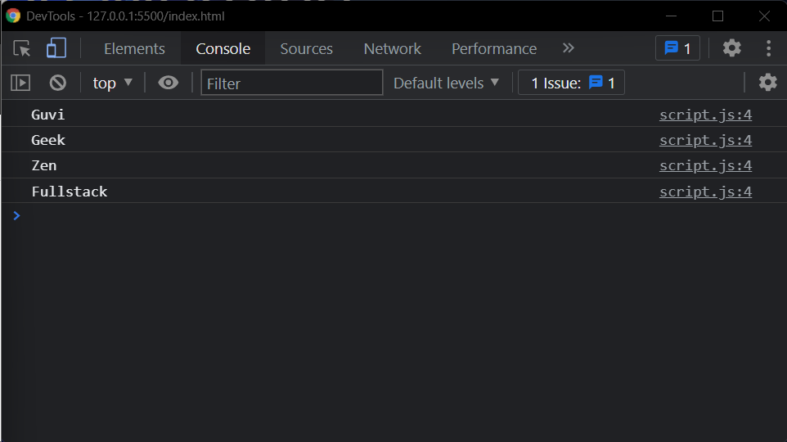

1. Fix the code to return the Prime numbers
2. Fix the code to sum the number in that array

const num = [10, 20, 30, 40,50,60,70,80,90,100]

let sum = (a, b) =>

a + b

sum = num.reduce(sum)

console.log(sum);

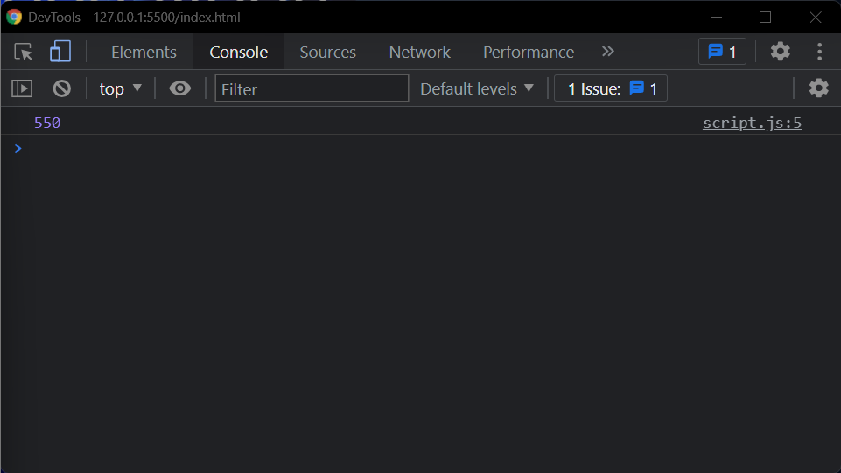

1. Fix the code to rotate an array by k times and return rotated array using IIFE function
2. Fix the code to gen Title caps.

var arr = ["guvi", "geek", "zen", "fullstack"];

(function() {

for (var i = 0; i <= arr.length; i++) {

console.log(arr[i][0].toUpperCase() + arr[i].slice(1));

}

})();

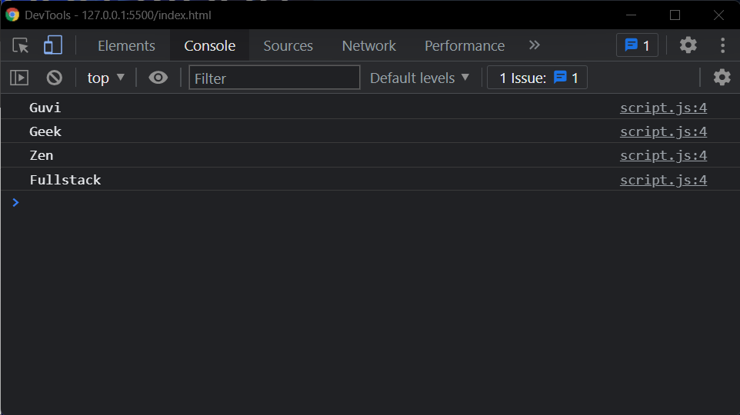

1. print all odd numbers in an array using IIFE function

var arr = [1, 2, 3, 5, 7, 79, 7, 2, 6, 9, 4];

(function() {

let array = []

for (var i = 0; i < arr.length; i++) {

if(arr[i] % 2 != 0) {

array.push(arr[i]);

}

}

console.log(array);

})();

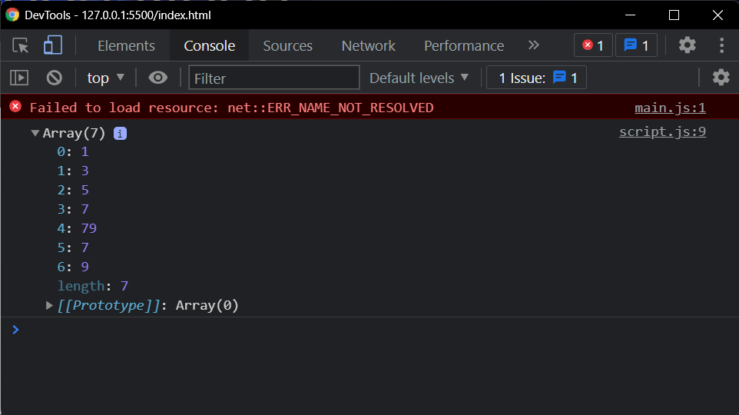

1. Fix the code to reverse.

(function(str){

let str1 = str.split("").reverse().join("");

console.log(str1);

})("abcd")

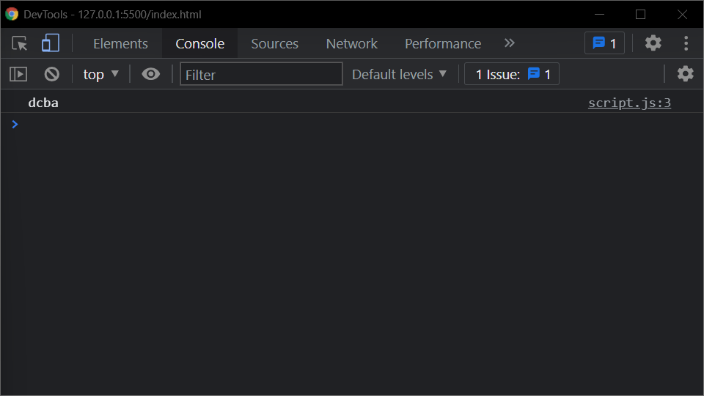

1. Fix the code to remove duplicates.

var res = function(arr){

newArr = [];

for(var i=0; i < arr.length; i++){

if(newArr.indexOf(arr[i]) == -1) {

newArr.push(arr[i]);

}

}

console.log(newArr)

}

res(["guvi","geek","guvi","duplicate","geeK"])

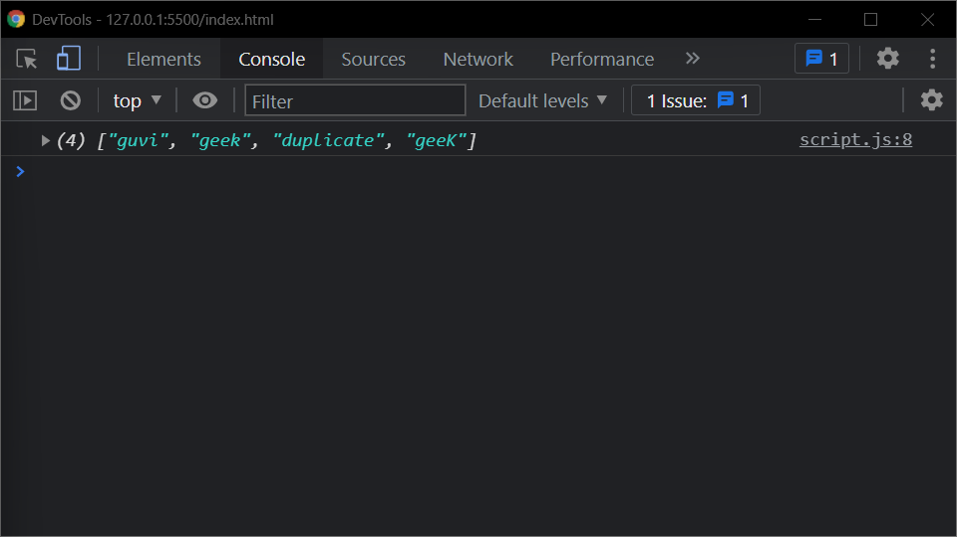

1. Fix the code to give the below output:

Expected Output:

[

{firstName: “Vasanth”, lastName: “Raja”, age: 24, role: “JSWizard”},

{firstName: “Sri”, lastName: “Devi”, age: 28, role: “Coder”}

]

let array =[[["firstname","vasanth"],["lastname","Raje"],["age",24],["role","JSWizard"]],[["firstname","Sri"],["lastname","Devi"],["age",28],["role","Coder"]]];

let final=[]

while(array.length!=0)

{

let outer_remove = array.shift();

let new_object = {}

while(outer_remove.length!=0)

{

let inner_remove = outer_remove.shift()

let key = inner_remove[0]

let value =inner_remove[1]

new_object[key]=value

}

final.push(new_object)

}

console.log(final)

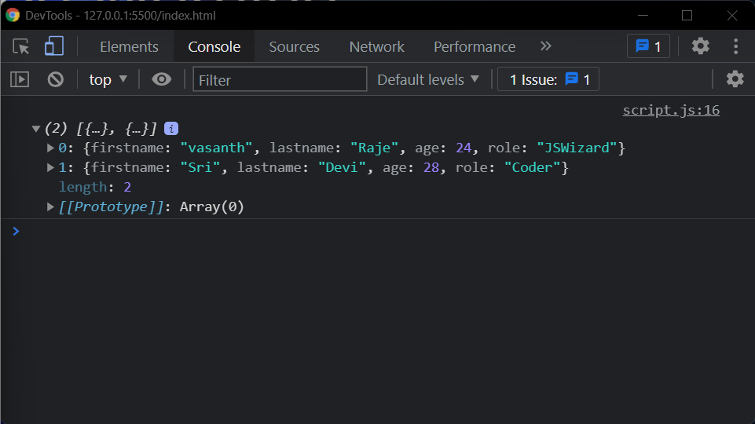

1. Fix the code to give the below output:

Sum of odd numbers in an array

let as = [12,34,5,6,2,56,6,2,1];

as.unshift(0)

let s=as.reduce(function(a,c){

if(c%2!=0){

return a+c;

}

return a;

});

console.log(s);

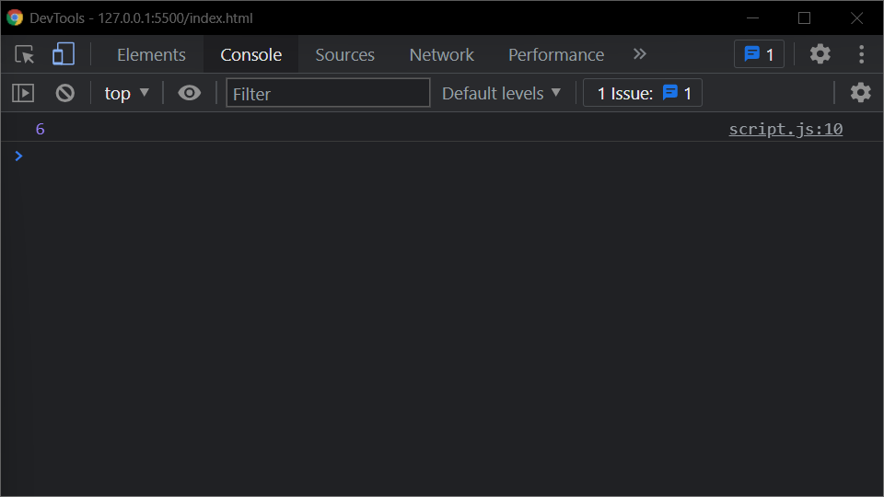

1. Fix the code to give the below output:

Swap the odd and even digits

# GUVI: Zen Class — Part 1: Find the culprits and nail them — debugging javascript

# Find the culprit and invoke the alert